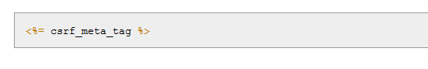

Rails code uses the Rails method **csrf_meta_tag** to prevent [cross-site request forgery](http://en.wikipedia.org/wiki/Cross-site_request_forgery) (CSRF), a type of malicious web attack.